**HW2 – Community detection**

1. **III. The results:**

|  |
| --- |
| Girvan-Newman: {'num_partitions': 11, 'modularity': 0.4776911064842356, 'partition': ….}  Louvain: {'num_partitions': 6, 'modularity': 0.5654156751933372, 'partition': ….}  Clique Percolation: {'num_partitions': 5, 'modularity': 0.43588024676049364, 'partition': …} |

the setting that yields the best modularity value is the Louvain algorithm.

The Clique Percolation algorithm reached the lowest modularity among the three algorithms. I found that some communities overlap with other communities and this fact interferes with the modularity calculation using the built-in function of the NetworkX package. Therefore, I used the function that we learned in practice to calculate the modularity.

Another problem I found is nodes that do not belong to any community and are not taken into account in this algorithm. Therefore, I created a set of vertices that are part of the community only and used this set for the modularity calculations.

In my ‘edge_selector_optimizer’ function I try to do the base function:

And I get the same result like without the optimizer.

I tried to improve the function so that we also refer to the weights of the edges:

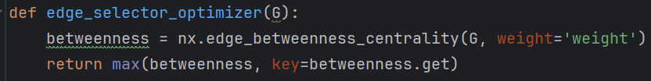

And the result are better, the modularity has increased but the number of communities doesn’t change:

|  |
| --- |
| Girvan-Newman with edge_selector_optimizer: {'num_partitions': 5, 'modularity': 0.5015935455086258, 'partition': …} |

Because the network we run on is weighted, and usually weights on the edges help to correctly identify communities.

1. **IV.** First, I found that as we increase the variable

**nodes_parliamentarians_non** the modularity of the graph will be compromised. This variable basically adds vertices that are not

"Main players", that is, less significant in the division into communities. This fact harms modularity. Actually, as much as possible

If we add more vertices that are not in the predefined group, the modularity will decrease:

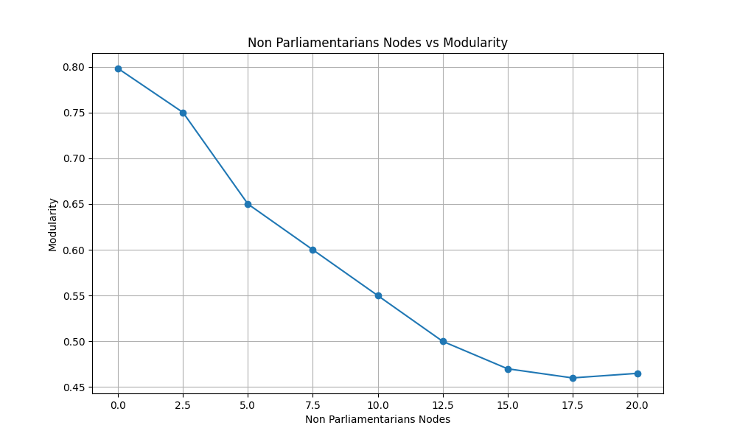

For comparison, I examine graphs with the variable nodes_parliamentarians_non equal to zero and ten, using all the data files in the date range 15.1.2019-15.04.2019. We will notice that after adding the vertices that are not main players, the division into communities changed significantly. Now, many more communities have been formed, which are "sub-communities" of the previous division. In addition, the modularity has dropped considerably (modularity before the addition was 0.822 compared to 0.422 after the addition) because there are now more communities with connections between them.

Lowering the modularity makes sense, as the added vertices are not major political actors and therefore have greater freedom with the messages they echo. Although they are likely to primarily endorse the political messages of the party they support, they may spread additional messages that will connect with multiple communities in the graph. In addition, it can be seen that the new vertices will change the structure of the communities, as they will add connections with the other vertices of the existing graph and cause the formation of new sub-communities according to the connections created.

Looking at the two attached graphs, it can be seen that in the graph containing only the main players, it is possible to distinguish the division into parties as well as the division into political right and left. The peaks of Gantz and Bibi, who were the main players in the elections to the 21st Knesset (April 9, 2019), constitute a center for the respective parties of that bloc. Also, it can be noticed that in every party the apex of the party leader is the central one for that community. It is also possible to distinguish the connections between the various parties according to their political affiliation and the connections between the blocs.

In addition, you can see political actors who belonged to one camp but echoed the political messages of actors from the opposite side. For example, you can see the vertex of Shelly Yachimovich, who belonged to the Labor Party, but had connections with vertices from the New Right Party community, and therefore in the division of the graph into communities belonging to this community. In the graph where additional players have been added, it is much more difficult to identify the division into blocks and it seems that many communities have been created that make it difficult to undesrstand the separation.

